EHR SOFA — Analysis for Revisons

January 14, 2022

Table of Contents

Q1: Run a sensitivity analysis excluding patients with an ICD-10 code for Operating Room (OR) on the day of mechanical ventilation. 1

Q2: How many patients had multiple admissions and had admissions excluded? Of these patients, were admission SOFA scores higher on subsequent admissions? 4

Q3: Discrimination of SOFA for predicting disposition to LTAC (long-term acute care) and prolonged mechanical ventilation. 5

Q4: What is AUC for SOFA > 11 vs < 11?* 6

Q5: Breaking down our primary outcome, how many patients died and how many were discharged to hospice.* 7

Q6: AUC for admission SOFA with mortality. AUC of change in SOFA score from admission to intubation (24 hours prior to intubation) with mortality. AUC for change in SOFA from admission to 3 days after intubation with mortality.* 7

### 

### Q1: Run a sensitivity analysis excluding patients with an ICD-10 code for Operating Room (OR) on the day of mechanical ventilation.

445 and 204 patients, who had surgery on the day of ventilation, were removed from the derivation and validation data respectively.

The following table shows AUC and odds ratio (95% CI) from logistic regression models using derivation cohort and validation cohort, separately. Results from this sensitivity analysis are similar to those from the primary analysis.

|  |  |  |  |  |
| --- | --- | --- | --- | --- |
| **Model** | **Variable** | **AUC (95% CI) Derivation Cohort**  **(N=9640)** | **AUC (95% CI)**  **Validation Cohort**  **(N=4833)** | **Logistic Regression**  **Odds ratio (95%CI)c** |
| SOFAa | SOFA | 0.658 (0.647,0.668) | 0.657 (0.642,0.671) | 1.392 (1.357, 1.428) |
| SOFA categoriesb | >=6 & <9 | 0.548 (0.542,0.553) | 0.542 (0.534,0.55) | 3.448 (2.906, 4.11) |
| >=9 and <12 | 4.998 (3.075, 8.593) |
| >=12 | 5.355 (1.766, 23.134) |
| Age | age | 0.712 (0.702,0.722) | 0.711 (0.696,0.725) | 1.059 (1.056, 1.063) |
| Age + SOFA Categories | age | 0.728 (0.718,0.738) | 0.723 (0.708,0.737) | 1.059 (1.055, 1.063) |
| >=6 & <9 | 3.228 (2.693, 3.887) |
| >=9 and <12 | 5.288 (3.171, 9.296) |
| >=12 | 5.991 (1.89, 26.583) |
| Age + SOFA | age | 0.748 (0.738,0.758) | 0.743 (0.729,0.757) | 1.056 (1.052, 1.06) |
| SOFA | 1.056 (1.052, 1.06) |
| SOFA + Age + Covariatesd | SOFA | 0.749 (0.74,0.759) | 0.744 (0.73,0.758) | 1.331 (1.296, 1.367) |
| age | 1.057 (1.053, 1.06) |
| Gender (M vs. F) | 1.143 (1.044, 1.252) |
| Obesity | 0.902 (0.77, 1.057) |
| Diabetes | 1.159 (1.032, 1.303) |
| Hypertension | 0.825 (0.738, 0.922) |
| SOFA + age + elixhauser score | age | 0.748 (0.738,0.758) | 0.743 (0.729,0.757) | 1.056 (1.052, 1.06) |
| elixhauser score | 1.056 (1.052, 1.06) |
| SOFA | 0.743 (0.729,0.757) |
| SOFA + elixhauser score | SOFA | 0.66 (0.649,0.671) | 0.661 (0.646,0.676) | 1.388 (1.353, 1.424) |
| elixhauser score | 1.031 (1.005, 1.058) |
| Categories SOFA + elixhauser score | >=6 & <9 | 0.564 (0.553,0.575) | 0.561 (0.546,0.577) | 3.375 (2.843, 4.025) |
| >=9 and <12 | 4.892 (3.008, 8.413) |
| >=12 | 5.302 (1.747, 22.911) |
| elixhauser score | 1.049 (1.023, 1.076) |

Two calibration plots were also generated excluding patients with an ICD-10 code for OR on the day of mv. These plots could be used to compare with Figure 2a and 2b from the manuscript. Again, we observed similar results between the primary analysis and this sensitivity analysis.

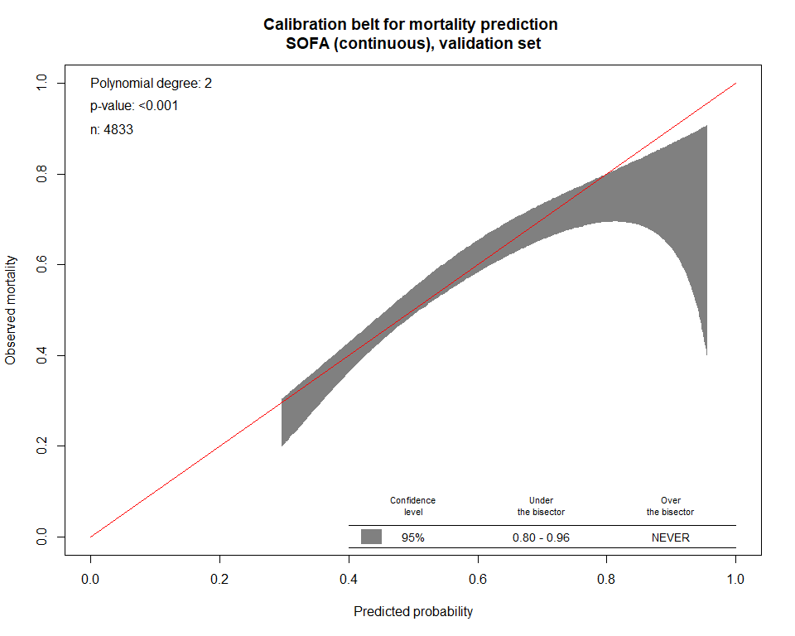

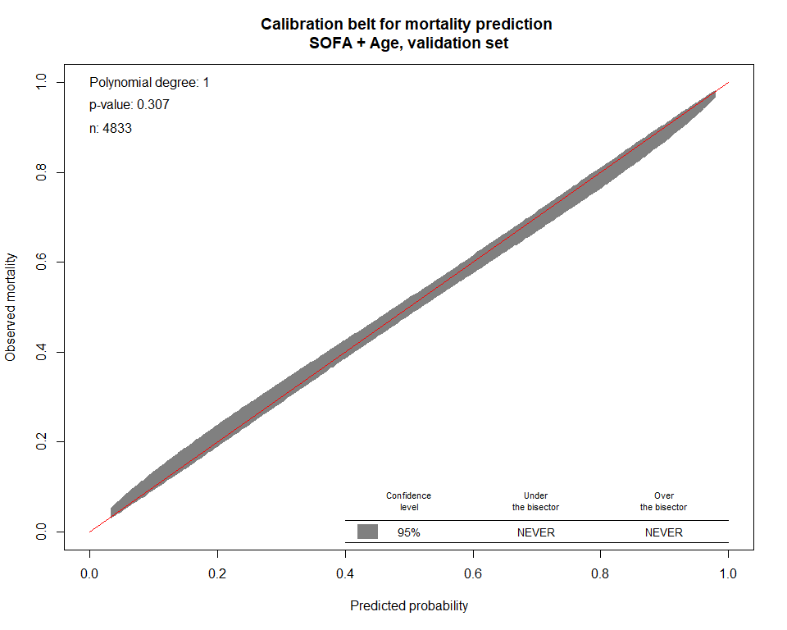

### 

### Q2: How many patients had multiple admissions and had admissions excluded? Of these patients, were admission SOFA scores higher on subsequent admissions?

6465 patients had been identified to have multiple admissions from the input data. After excluding patients who were on mechanical ventilation at admission and/or had a designation of DNR status at admission, we ended up with 711 patients, who were included in the primary analysis.

For those 711 patients, one admission was randomly selected to be used in the analysis (789 out of 1500 encounters had been excluded.).

The following frequency table shows number of admissions for this patient group. From the table, we observed that the majority of the readmitted patients had 2 or 3 times of admission.

|  |  |
| --- | --- |
| NumberOfAdmission | Freq |
| 2 | 641 |
| 3 | 64 |
| 4 | 5 |
| 6 | 1 |

The median sofa is 2 for the 1st admission, and it is 2 for the 2nd and 2 for the 3rd. Density plots were constructed by the times of admission. Two-sample t-test and Wilcoxon rank sum test didn’t detect any significant difference in admission sofa score between the 1st and the 2nd, or between the 1st and the 3rd admission.

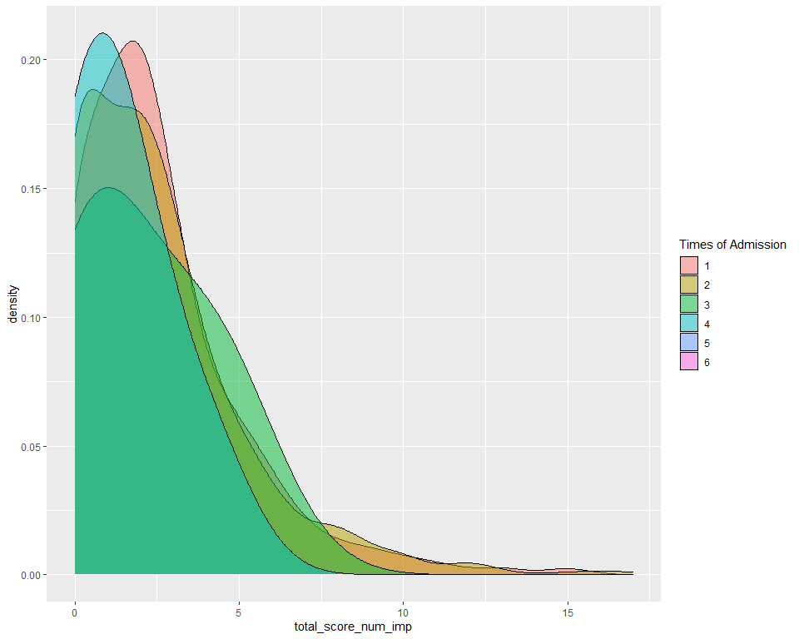

### Q3: Discrimination of SOFA for predicting disposition to LTAC (long-term acute care) and prolonged mechanical ventilation.

Note:

From the input data, two types of discharge were considered as disposition to LTAC, which are “DISCHARGED/TRANSFERRED TO A MEDICARE CERTIFIED LONG TERM CARE HOSPITAL (LTCH) WITH A PLANNED ACUTE CARE HOSPITAL INPATIENT READMISSION” and "DISCHARGED/TRANSFERRED TO A MEDICARE CERTIFIED LONG TERM CARE HOSPITAL (LTCH).

In this analysis, mechanical ventilation time longer than 96 hours is considered as prolonged mechanical ventilation.

Sofa score used in these prediction models were sofa recorded within 24 hours prior to mv.

**SOFA in prediction of disposition to LTAC**

|  |  |  |  |
| --- | --- | --- | --- |
| AUC.train | AUC.test | term | OR |
| 0.504 (0.474,0.534) | 0.529 (0.486,0.573) | Pre1day_total_score_num_imp | 0.987 (0.93, 1.044) |

### 

**SOFA in prediction of prolonged mechanical ventilation**

|  |  |  |  |
| --- | --- | --- | --- |
| AUC.train | AUC.test | term | OR |
| 0.567 (0.485,0.649) | 0.522 (0.38,0.664) | Pre1day_total_score_num_imp | 0.913 (0.779, 1.053) |

### 

**SOFA in prediction of disposition to LTAC and/or prolonged mechanical ventilation**

|  |  |  |  |
| --- | --- | --- | --- |
| AUC.train | AUC.test | term | OR |
| 0.512 (0.483,0.54) | 0.528 (0.486,0.57) | Pre1day_total_score_num_imp | 0.979 (0.926, 1.033) |

### 

### Q4: What is AUC for SOFA > 11 vs < 11?*

|  |  |  |  |
| --- | --- | --- | --- |
| Variable | AUC.train | AUC.test | OR |
| Binary variable of sofa<11 vs >=11 | 0.502 (0.501,0.504) | 0.501 (0.5,0.502) | 7.25 (2.851, 24.462) |

Logistic regression model was constructed using binary sofa score with 11 as the cutoff to predict in-hospital death. Based on this model AUC (95% CI) is 0.502 (0.501,0.504) using the derivation set and is 0.501 (0.5,0.502) using the validation set. Again, this binary sofa was derived on sofa score recorded within 24 hours prior to mv. Note that the odds ratio is statistically significant indicating that patients with sofa score >=11 have 7 times higher chance to die relative to patients with sofa score <11, although the discrimination performance of this model is bad.

### 

### Q5: Breaking down our primary outcome, how many patients died and how many were discharged to hospice.*

In the derivation set, 4776 out of 5055 (94.48%) patients died, whereas 279 out of 5055 (5.52%) patients were discharged to hospice.

In the validation set, 2362 out of 2513 (93.99%) patients died, whereas 151 out of 2513 (6.01%) patients were discharged to hospice.

### 

### Q6: AUC for admission SOFA with mortality. AUC of change in SOFA score from admission to intubation (24 hours prior to intubation) with mortality. AUC for change in SOFA from admission to 3 days after intubation with mortality.*

For each of the 3 sofa measurements (sofa at admission, sofa change from admission to 24 hours prior to mv, and sofa change from admission to 3 days post mv), logistic regression models were fit to predict mortality using derivation and validation set, separately. AUC outputs and odds ratio results were shown in the tables followed by stacked-bar plots to visualize proportion of died across sofa values.

**admission SOFA with mortality**

|  |  |  |  |
| --- | --- | --- | --- |
| Variable | AUC.train | AUC.test | OR |
| sofa at admission | 0.621 (0.611,0.632) | 0.612 (0.597,0.628) | 1.274 (1.245, 1.304) |

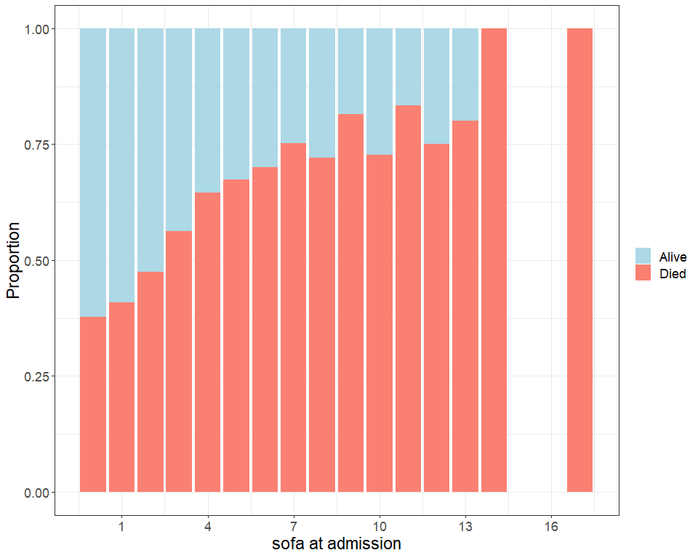

**change in SOFA score from admission to intubation (24 hours prior to intubation) with mortality**

|  |  |  |  |
| --- | --- | --- | --- |
| Variable | AUC.train | AUC.test | OR |
| sofa change from admission to intubation (24 hours prior to intubation) | 0.531 (0.521,0.542) | 0.539 (0.524,0.554) | 1.104 (1.075, 1.134) |

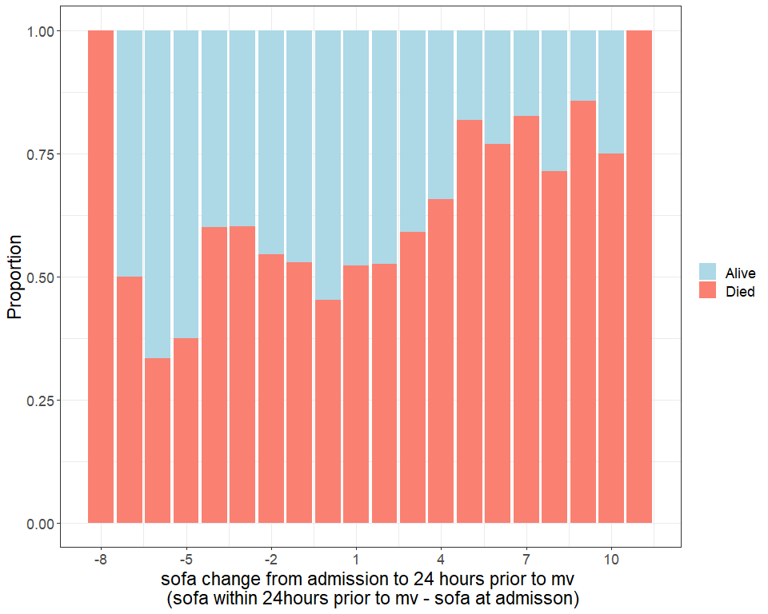

**change in SOFA from admission to 3 days after intubation with mortality**

Note: Compared to the other 2 measurements, about 13% patients don’t have sofa score available 3 days post intubation, and 2/3 of them were deceased before 3 days post intubation.

|  |  |  |  |
| --- | --- | --- | --- |
| Variable | AUC.train | AUC.test | OR |
| sofa change from admission to 3 days after intubation | 0.708 (0.697,0.718) | 0.693 (0.677,0.708) | 1.287 (1.267, 1.307) |

